**Heavy duty paper core shredder**（**Model:1000 Capacity**：**3t/h**）

***Contact:Faško Ján***

***Email :Faskojan83@gmail.com***

**Email :faskojan83@gmail.com**

**Machine picture**

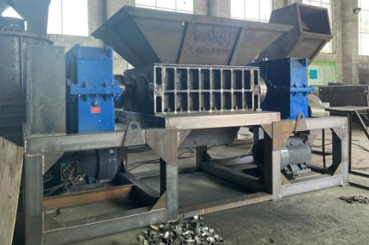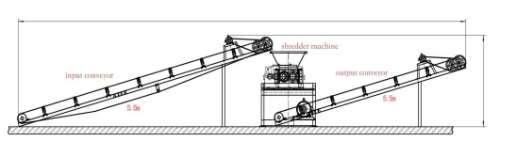— 3 —

***Quotation***

|  |  |  |  |
| --- | --- | --- | --- |
| **Name** | **Price** | **Capacity** | **Power** |
| **Heavy double shaft shredder**  **for wood,paper and oder**  **materials** | **DAP**  **58000€** | **3000kg/h** | **45KW+**  **45KW** |

***Note***： ***Motor:We will change the motor to 45KW+45KWfree of charge.. Normal*** ：***37kw+37kw.***

***Reducer:Reducer model increased to 750.***

***Nomal:model 450.***

**Payment terms**

◎ **Payment terms:The deposit is 30%, balance payment is paidbefore delivery**

◎ **Packaging:Standard export packing.**

◎ **DAP**

◎

◎ **Validity of quotation :The quoted prices are valid for 30 days andthereafter subject to our written confirmation.**

◎ **Price changes subject to: configuration adjust, variation of morethan 2% in euro rate, raw material cost.**

◎ **Delivery : We will dispatch the equipment on order with 90 working days from the date of advance payment, fromthe countryof origin.The dispatch is subject to Force Majeure conditions as specified in this offer.**

**Configuration for shredder**

|  |  |  |  |
| --- | --- | --- | --- |
| **NO** | **ITEM** | **DESCRIPTION**  **(*MODEL 1000)*** | **QUANTITY** |
| **1** | **Input rubber conveyor** | Dimensions :5000*600mm | **1**  motor. |
| Thickness:5mm |
| Power:1.5kw,with adjustable speed |
| **2** | **Double shaft shreddermachine** | Model:1000 | **1** be |
| Chamber size:1000*690mm |
| Power:45kw*2 |
| Machine frame:1.2*1.2ms quare pipematerials. |
| Hopper dimensions:1.5*1m(Hopper canadded free of charge). |
| Overall size:4.1* 2.1*2.7m |
| Blade quantity:20pcs |
| Material of blade:D2 |
| **3** | **Main form** | Discharge size:50-150mm | **1** |
| Split type frame for easy dis-assembly,adopt Q345 welding forresistance, highabrasion strength Thickness of shredder chamber size:20mm |
| Machine power:45*2kw |
| Machine reducer:JZQ-750/Brand:zhengtai |
| Machine frame:1.2*1.2ms quare pipematerials. |
| **3** | **Blade** | Quaninty:20pcs | **1** |
| Material of blade:D2 |

— 5 —

|  |  |  |  |
| --- | --- | --- | --- |
|  |  | Blade type:Normal one-piece knifedetachable) | (not        angle |
| Blade hardness range:60-62 HRC |
| Blade diameter:400mm |
| Blade thickness:50mm |
| Blade shape:External teeth use a smallhook angle outside the trianglesteeptooth type, within the use of internalholehexagonal type. |
| Blade teeth:8 teeth |
| **6** | **Shaft** | Shape:Hexagonal axis | **1** |
| Raw material:H13 |
| Diameter:180mm |
| **7** | **Sleeve** | Raw material:H13 | **1** |
| Quantity:20pcs |
| **8** | **Bearing** | Double row self-aligning roller bearingwith locking sleeve. | **1** |
| **9** | **Connection** | Coupling between reducer to shredder, rubber belt for motor and reducer. | **1** |
| **10** | **Control electric cabinet** | Emergency Stop Automatically reverse when electriccurrent overloaded | **1** |
| **11** | **Output rubber conveyor** | Dimensions :5000*600mm | **1**  motor. |
| Thickness:5mm |
| Power:1.5kw,with adjustable speed |

— 6 —

**Blade**

