**QUOTATION OF MINI780H WHEEL LOADER**

Delivery time: About 80 working days upon receipt of deposit

Warranty: 12 months

Packing: 2 sets/20GP; 5 or 6 sets/40HQ (change with small iron wheels when loading)

Price List

|  |  |  |  |
| --- | --- | --- | --- |
| **Model** | **Picture** | **Standard Configurations** | **DAP Price (EUR)** |
| **Mini780H**  (Hydrostatic system) | **IMG_1418** | Kubota V1505 Euro 5/EPA 4 engine 18.2kw, 4WD, 31x15.5-15 tires, electronic joystick, standard bucket, VARTA Battery, floating function,adjustable steering wheel and seat, back sound, hand brake, tool box. Standard with 3 hydraulic lines;  Quick hitch included, | **24000** |

Option Configuration

|  |  |
| --- | --- |
| **Option** | **Price（USD）** |
| Enclosed cabin with heater | Included |
| 4 Hydraulic line | +€450 |
| Change to Xinchai E5 engine | -€1000 |
| Change to Perkins 403J-11T EPA/E5 engine | +€580 |
| Electric air conditioning | +€450 |

Attachments

|  |  |  |  |
| --- | --- | --- | --- |
| Pallet fork | € 570 | Grass fork | €1100 |
| Hydraulic adjustable pallet fork | € 1450 | Snow bucket | €1000 |
| Snow blade with spring | €1300 | Auger | €1500 |
| V Blade | €1000 | Bale spear(2&3 teeth) | €1100 |
| 4 in 1 bucket | €1000 | Open Sweeper | €1400 |
| Drum clamp | €1000 | Closed street sweeper | €1800 |
| digger arm (Backhoe bucket) | €1500 | Log clamp (H model/A model) | €1350 |
| Dustpan bucket | €900 | Grass bucket | €960 |
| Lifting arm | €1200 | New European grass fork | €1220 |
| Pitch fork | €980 | Bale grab | €1100 |
| Grass cutter | €1350 |  |  |
| Dustpan bucket | €900 | Grass bucket | €960 |

Specifications

|  |  |  |
| --- | --- | --- |
| Whole drive system | Italy Hydrostatic system with high oil flow | |
| Specification | Overall weight (kg) | 2500 (with cab) |
| 2300 (with roll bar) |
| L×W×H（mm） | 4036 X 1446 X 2260 |
| Rated bucket capacity(m3) | 0.3-0.4 |
| Rated load(kg) | 800 |
| Dump height (mm) | 1980 |
| Dump distance(mm) | 800 |
| Wheel base(mm) | 1595 |
| Thread(mm) | 1101 |
| Total time(s) | 7.3 |
| Engine | Model | Kubota V1505 E5/EPA |
| Rated power（KW） | 18.2 |
| Rated speed(r/min) | 2300 |
| Steering system | Max. turning angle(°) | 42 |
| Min turning radius(mm) | 3436MM |
| Hydraulic system | Working pressure | 16Mpa |
| Boom lifting time | 4.2s |
| Tires | Standard tires | 31x15.5-15 |
| Standard bucket | Width (mm) | 1446 |

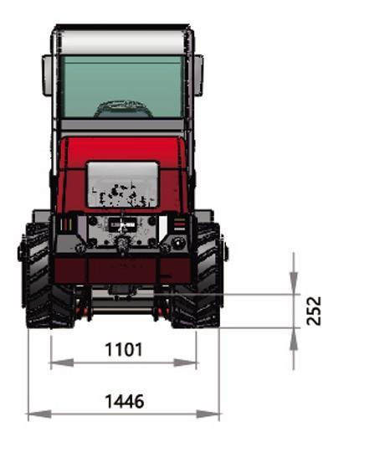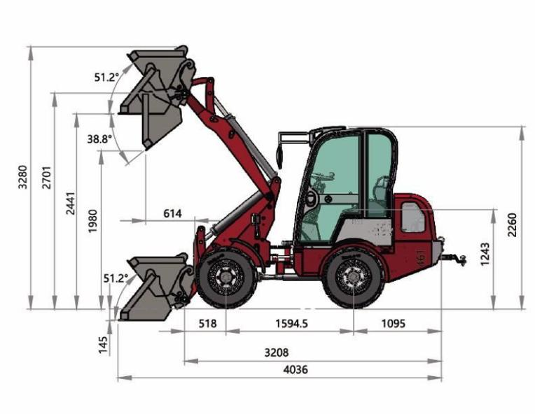

Pictures

|  |  |
| --- | --- |
| mini 780H in UK (3)  Pictures | 微信图片_20240412091203 |
| Poland (2) | 微信图片_20240409092732 |
|  | C:/Users/Administrator/AppData/Local/Temp/picturecompress_20220322165952/output_1.jpgoutput_1 |
|  |  |